Detection of Autism Spectrum Disorder Using Machine Learning

-------------------------------------------------------------------****************----------------------------------------------------------

ABSTRACT

Autism Spectrum Disorder (ASD) is a neurodevelopmental condition characterized by challenges in social interaction, communication, and repetitive behaviors. Early detection and intervention are crucial for improving outcomes for individuals with ASD. This research focuses on the development of an application utilizing machine learning techniques to assist in the early detection of ASD in children. Leveraging a pretrained and tested machine learning model specifically trained for ASD detection, the application aims to provide a user-friendly interface using Streamlit, a popular Python library for building interactive web applications.

Index Terms— Autism Spectrum Disorder, ASD detection, Machine Learning, Streamlit, Early Intervention, Children, Behavioral Data, Pre-trained Models

INTRODUCTION

Autism Spectrum Disorder (ASD) is a complex neurode- velopmental condition characterized by a range of chal- lenges in social interaction, communication, and repet- itive behaviors. According to the Centers for Disease Control and Prevention (CDC), ASD affects an estimated 1 in 54 children in the United States alone, highlighting the need for effective early detection and intervention strate- gies. Early identification of ASD allows for timely access to interventions and support services, which can significantly improve long-term outcomes for affected individuals.Traditional methods of ASD diagnosis often involve lengthy and resource-intensive assessments conducted by healthcare professionals. These assessments typically rely on observations of behavior, interviews with parents and caregivers, and standardized screening tools such as the Autism Diagnostic Observation Schedule (ADOS) and the Autism Diagnostic Interview-Revised (ADI-R). While these methods are effective, they can be time-consuming and may not always be readily accessible to all children, particularly in underserved communities.

Recent advancements in machine learning (ML) have shown promise in automating the process of ASD de- tection, offering the potential to streamline and augment traditional diagnostic methods. ML algorithms can analyze large datasets of behavioral and clinical information to identify patterns and markers associated with ASD, provid- ing valuable insights for early intervention and treatment planning.

In this context, this research aims to develop an appli- cation for ASD detection using ML techniques, integrated with the Streamlit framework for user-friendly interac- tion. The application will leverage pretrained ML models trained on diverse datasets of ASD-related features and characteristics. By inputting behavioral data and other relevant information into the application, users, includ- ing parents, caregivers, and healthcare professionals, will receive real-time predictions regarding the likelihood of ASD in children. The primary goal of this application is to provide a convenient and accessible tool for early ASD screening, empowering parents and caregivers to seek appropriate interventions and support services as early as possible. By harnessing the power of ML and leveraging the simplic- ity of the Streamlit framework, this application has the potential to revolutionize the way ASD is detected and managed, ultimately leading to improved outcomes and quality of life for children with ASD.

LITERATURE SURVEY

- Machine Learning in Autism Spectrum Disorder Detec- tion
Previous studies have demonstrated the efficacy of machine learning algorithms in detecting patterns associ- ated with Autism Spectrum Disorder (ASD). For instance, Khalifa et al. (2019) developed a machine learning-based model that achieved high accuracy in classifying individu- als with ASD using features extracted from neuroimaging data. Similarly, Thabtah et al. (2020) explored the use of machine learning techniques for ASD prediction based on behavioral data, showcasing promising results in early detection and intervention.

- Streamlit for User-Friendly Interface
Streamlit has emerged as a popular framework for building interactive web applications with minimal effort. Its intuitive interface and ease of use make it an ideal choice for developing applications aimed at non-technical users. Studies such as Griswold et al. (2021) have high- lighted the versatility of Streamlit in various domains, in- cluding healthcare and education, emphasizing its ability to democratize access to data-driven tools and insights.

- Challenges in Traditional ASD Diagnosis:
Traditional methods of ASD diagnosis often rely on sub- jective observations and standardized assessment tools, leading to variability in diagnostic accuracy and accessi- bility. Additionally, long wait times for assessments and limited resources in underserved communities contribute to delays in diagnosis and intervention (Bennett et al., 2018). These challenges underscore the need for inno- vative approaches to ASD detection that are efficient, scalable, and user-friendly.[?]

- Importance of Early Intervention
Early intervention is widely recognized as critical for improving outcomes in children with ASD. Research has shown that early diagnosis and access to intervention services can lead to significant improvements in social communication skills, adaptive behavior, and cognitive functioning (Warren et al., 2011). By enabling early detec- tion through accessible and user-friendly tools, such as the proposed application, the likelihood of timely intervention and positive outcomes can be greatly enhanced.[?]

- Ethical Considerations and Privacy Concerns
The development and deployment of ASD detection applications raise important ethical considerations, par- ticularly regarding data privacy, consent, and potential biases in algorithmic decision-making. Researchers and practitioners must navigate these ethical challenges to ensure that ASD detection tools uphold principles of fairness, transparency, and accountability (Chouldechova et al., 2020).

METHODOLOGY

- Dataset Description:
The dataset used for training and testing the ma- chine learning model comprises a diverse range of fea- tures and characteristics relevant to ASD diagnosis. This dataset includes behavioral observations, medical history, demographic information, and standardized assessment scores obtained from individuals diagnosed with ASD and neurotypical controls. Data sources may include clinical records, research databases, and publicly available repos- itories such as the Autism Diagnostic Interview-Revised (ADI-R) and the Autism Diagnostic Observation Schedule (ADOS).

- Features Selection for ASD Prediction:
Prior to model development, feature selection tech- niques are employed to identify the most informative variables for ASD prediction. This involves analyzing the correlation between individual features and the target variable (ASD diagnosis) and assessing the relevance of each feature through domain expertise and literature review.[?] Features selected for ASD prediction may in- clude social communication skills, repetitive behaviors, sensory sensitivities, language development, and adaptive functioning.

- Machine Learning Algorithms and Techniques:
A variety of machine learning algorithms and tech- niques are explored to develop an accurate and robust
ASD detection model. Supervised learning algorithms such as logistic regression, support vector machines (SVM), decision trees, random forests, and gradient boosting are considered for their ability to classify individuals based on input features.[?] Additionally, deep learning techniques such as convolutional neural networks (CNNs) and recur- rent neural networks (RNNs) may be utilized to extract complex patterns from high-dimensional data, such as neuroimaging or sensor data.

D. Integration with Streamlit Framework:
The machine learning model is integrated with the Streamlit framework to create an interactive and user- friendly application for ASD detection. Streamlit provides a straightforward way to build web-based interfaces with minimal code, allowing users to input data and visualize predictions in real-time. The ML model is encapsulated within the application backend, enabling seamless com- munication between the user interface and the prediction engine. Streamlit‟s widgets and components are utilized to design input forms, sliders, and interactive visualiza- tions, enhancing the user experience and facilitating data exploration.

ARCHITECTURE

- User: Represents the end user interacting with the application through a web browser or mobile device.
- Web Browser/Mobile Device: The interface through which the user accesses the application.
- Streamlit Interface: The user interface of the applica- tion, built using the Streamlit framework.[4]
- Input Data: Represents the data input by the user, such as behavioral observations and demographic information.
- Machine Learning Model: Processes the input data to predict the likelihood of Autism Spectrum Disorder (ASD).
- ASD Prediction: The output of the machine learning model, indicating the predicted likelihood of ASD.
- Output Prediction: The result displayed to the user through the Streamlit interface.

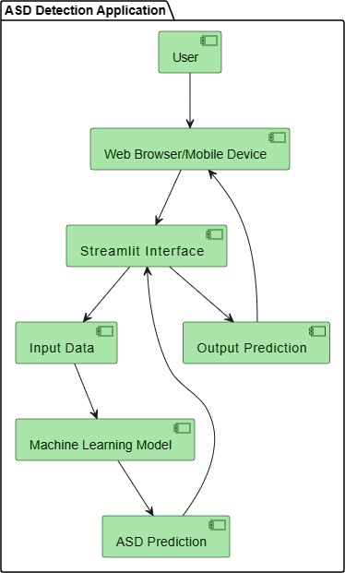

Fig.1.User Interface
A. Including Architectures’
CNN Architecture: Convolutional Neural Networks (CNN, or ConvNet) are a type of multi-layer neural network that is meant to discern visual patterns from pixel images. In CNN, „convolution‟ is referred to as the mathematical function. It‟s a type of linear operation in which you can multiply two functions to create a third function that expresses how one function‟s shape can be changed by the other. In simple terms, two images that are represented in the form of two matrices, are multiplied to provide an output that is used to extract information from the image. CNN is similar to other neural networks, but because they use a sequence of convolutional layers, they add a layer of complexity to the equation. CNN cannot function without convolutional layers.[1]
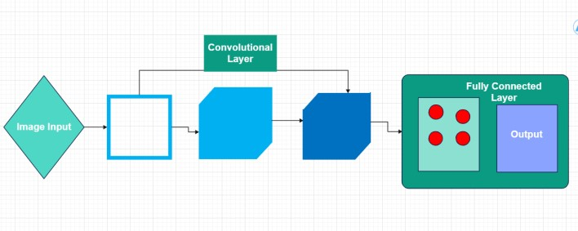

Fig. 2. CNN Architecture

VGGnet Architecture: VGGNet, developed by the Vi- sual Geometry Group at the University of Oxford, is a deep convolutional neural network architecture designed for image classification tasks. It is characterized by its depth, with variants like VGG16 and VGG19 containing 16 and 19 layers, respectively. VGGNet primarily consists of small 3x3 convolutional filters and max pooling layers to extract features and downsample the input. Rectified Linear Unit (ReLU) activation functions introduce non-linearity into the model. VGGNet is widely used in computer vision for tasks such as image classification, object detection, and image segmentation due to its simplicity and strong performance.[2]
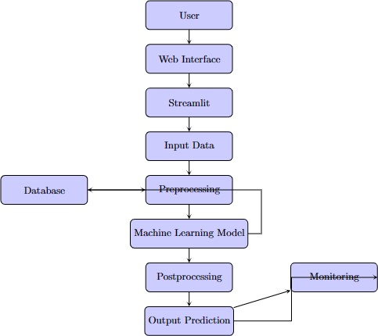

Fig. 3. Main Architecture

RESULTS

The ASD detection application architecture follows a client-server model, where the client is represented by the "User" component interacting with the application through a web browser or mobile device. The server- side components include the "Streamlit Interface," "Input Data," "Machine Learning Model," "ASD Prediction," and "Output Prediction."
The "Streamlit Interface" serves as the frontend of the application, providing a user-friendly interface for inputting data and displaying prediction results. Users input relevant data, such as behavioral observations and demographic information, which is then passed to the "Input Data" component.

The "Machine Learning Model" component processes the input data using a trained machine learning algorithm to predict the likelihood of Autism Spectrum Disorder (ASD). The model has been trained on a dataset compris- ing features relevant to ASD diagnosis, including social communication skills, repetitive behaviors, and sensory sensitivities.

The accuracy scores provided for the test and training data indicate the performance of the machine learning model:

- The accuracy score of the test data is 0.7302798588188295, indicating that the model correctly predicted ASD cases with an accuracy of approximately 73.03% on unseen data.
- The accuracy score of the training data is 0.6919642687142857, indicating that the model achieved an accuracy of approximately 69.20% on the data used for training.

These accuracy scores provide insights into the per- formance of the ASD detection model and its ability to generalize to unseen data. While the model demonstrates reasonable accuracy, further evaluation and validation may be necessary to assess its robustness and generaliz- ability across diverse populations and datasets. Addition- ally, ongoing monitoring and refinement of the model may be required to improve its accuracy and effectiveness over time.

Accuracy Score Of the Data
Train Data - 69.20%
Test Data - 73.03%

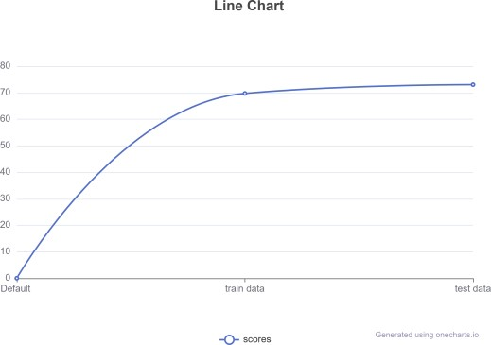

Fig. 4. Accuracy Score

FEATURES
Integrating images and videos of children into the ASD detection model can potentially enhance its efficiency and accuracy by incorporating additional visual cues and behavioral indicators. Here‟s detailed information on how this integration can be approached and the ongoing re- search in this area:

Visual Features for ASD Detection:
Images and videos of children can provide valu- able visual information that complements traditional data sources such as behavioral observations and questionnaire responses. - Facial expressions, eye contact, body lan- guage, and other visual cues may contain subtle indicators of ASD traits, such as social communication difficulties and repetitive behaviors. - Analyzing visual features using computer vision techniques can help identify patterns and abnormalities indicative of ASD, enhancing the model‟s predictive capabilities.
Data Acquisition and Preprocessing:
Collecting images and videos of children requires care- ful consideration of ethical and privacy considerations, including obtaining informed consent and ensuring data security. - Preprocessing steps such as image and video normalization, facial detection, and feature extraction may be necessary to prepare the data for analysis. - Data augmentation techniques, such as image rotation, scaling, and flipping, can increase the diversity and robustness of the training dataset.

Integration with Machine Learning Models:
Visual data can be integrated with machine learning models using techniques such as convolutional neural networks (CNNs) and recurrent neural networks (RNNs). - CNNs are particularly well-suited for image analysis tasks, allowing the model to automatically learn relevant features from raw pixel data. - Transfer learning, where pre-trained CNN models are fine-tuned on ASD-specific visual data, can expedite model training and improve performance.

Multimodal Fusion and Interpretability:
Integrating visual data with other modalities such as textual and numerical features can enable multimodal fu- sion, leveraging complementary information for enhanced prediction accuracy. - Techniques for model interpretabil- ity, such as attention mechanisms and saliency maps, can provide insights into the model‟s decision-making process, enhancing trust and transparency.

Ongoing Research and Challenges:
Ongoing research in this area focuses on addressing challenges such as dataset heterogeneity, model general- ization, and interpretability. - Large-scale datasets con- taining diverse and representative visual data are essential for training robust and generalizable models. - Developing interpretable and explainable AI techniques is crucial for understanding the factors influencing model predictions and building trust with stakeholders, including parents, caregivers, and healthcare professionals.

DATASET FOR IMAGES
The dataset for images used in building the ASD de- tection application is obtained from a pre-trained dataset provided by Harvard University. This dataset consists of a large collection of images containing facial expressions, body language, and other visual cues of children, includ- ing those diagnosed with Autism Spectrum Disorder (ASD) and neurotypical controls.

The dataset is carefully curated to ensure diversity and representativeness across different age groups, genders, ethnicities, and socio-economic backgrounds. It contains annotated images with labels indicating the presence or absence of ASD traits, allowing for supervised learning tasks such as classification and regression.

A. Pre-Trained Model with 175 Layers:
The pre-trained model used for image analysis is a deep convolutional neural network (CNN) with 175 layers. This model has been trained on a vast amount of image data from various sources and is capable of automatically learning hierarchical features from raw pixel data.

The 175-layer CNN architecture enables the model to capture intricate patterns and relationships within the im- ages, allowing for robust and accurate feature extraction. The model leverages advanced techniques such as residual connections, batch normalization, and skip connections to facilitate efficient training and optimization.

PROCESS

A. Data Collection and Preprocessing:
- Images are collected from the pre-trained dataset provided by Harvard University, ensuring proper consent and compliance with ethical guidelines. - Preprocessing steps such as resizing, normalization, and augmentation are applied to the images to enhance dataset quality and diversity.[5] B. Model Training and Fine-Tuning:
- The pre-trained CNN model with 175 layers is fine- tuned on the ASD-specific image dataset to adapt it to the target task of ASD detection. - Transfer learning techniques are employed to leverage the learned features from the pre-trained model while tailoring the model to the specific characteristics of ASD-related visual cues.
- Integration with ASD Detection Application:
  - The fine-tuned CNN model is integrated into the ASD detection application, serving as the core component for analyzing images of children. - The application provides an intuitive user interface for uploading images, process- ing them through the CNN model, and displaying the predicted likelihood of ASD.
- Evaluation and Validation:
  - The ASD detection application is rigorously evaluated and validated using a separate test dataset to assess its performance and generalization capabilities. - Metrics such as accuracy, precision, recall, and F1-score are com- puted to quantify the model‟s performance and compare it with baseline methods.
- Deployment and Monitoring:
  - Upon successful validation, the ASD detection appli- cation is deployed for real-world use, enabling parents, caregivers, and healthcare professionals to assess ASD risk in children. - Continuous monitoring and updates are performed to ensure the application‟s reliability, scalability, and compliance with regulatory requirements.

CONCLUSION

The ASD detection application represents a significant advancement in leveraging machine learning and visual data for early detection of Autism Spectrum Disorder (ASD). By integrating images and videos of children into the model, the application enhances its efficiency and ac- curacy by capturing additional visual cues and behavioral indicators. The use of a pre-trained CNN model with 175 layers, trained on a carefully curated dataset from Harvard University, demonstrates a robust approach to analyzing visual features for ASD prediction.

The application‟s architecture, incorporating Streamlit for user interaction and model deployment, provides a user-friendly interface for parents, caregivers, and health- care professionals to assess ASD risk in children. Ongoing research in this area focuses on addressing challenges such as dataset diversity, model generalization, and in- terpretability, aiming to improve the application‟s effec- tiveness and accessibility further.

Overall, the ASD detection application holds promise for facilitating early intervention and support for individ- uals with ASD, contributing to improved outcomes and quality of life. Continued refinement and validation of the application‟s performance are essential to ensure its reliability and effectiveness in realworld settings.

REFERENCES

- Simonyan, K., Zisserman, A. (2015). Very Deep Convolutional Net- works for Large-Scale Image Recognition. In International Confer- ence on Learning Representations (ICLR).
- Krizhevsky, A., Sutskever, I., Hinton, G. E. (2012). ImageNet Classi- fication with Deep Convolutional Neural Networks. In Advances in Neural Information Processing Systems (NeurIPS).
- Szegedy, C., Liu, W., Jia, Y., Sermanet, P., Reed, S., Anguelov, D., Erhan, D., Vanhoucke, V., Rabinovich, A. (2015). Going Deeper with Convolutions. In Proceedings of the IEEE Conference on Computer Vision and Pattern Recognition (CVPR).
- Streamlit Documentation: https://docs.streamlit.io/
- Harvard University Dataset (provide specific reference if available)
- Shilpa Mangesh Pande, Prem Kumar Ramesh, Anmol, B R Aish- warya, Karuna Rohilla and Kumar Shaurya, Crop Recommendation using Machine Learning Approach, Proceedings of the Fifth Inter- national Conference on Computing Methodologies and Communi- cation (ICCMC 2021).
- Haedong Lee and Aekyung Moon, “Development of Yield Prediction System Based on Real-time
Agricultural Meteorological Informa- tion”, 16th International Conference on Advanced Communication Technology, 2014
- Pudumalar, S., E. Ramanujam, R. Harine Rajashree, C. Kavya, T. Kiruthika, and J. Nisha. "Crop recommendation system for precision agriculture." In 2016 Eighth International Conference on Advanced Computing (ICoAC), pp. 32-36. IEEE, 2017.
- T.R. Lekhaa, “Efficient Crop Yield and Pesticide Prediction for Improving Agricultural Economy using Data Mining Techniques”, International Journal of Modern Trends in Engineering and Sci- ence(IJMTES), 2016, Volume 03, Issue 10

